What my website will include:

Information about good computer companies – listed in the order of how good their best computer is. Then, show the best computer/s that the company makes. These will be listed in a chart later as top 5. Companies are:

1. Asus
2. MSI
3. Razer Blade
4. Alienware
5. Origin pc

**Asus Pictures:**

[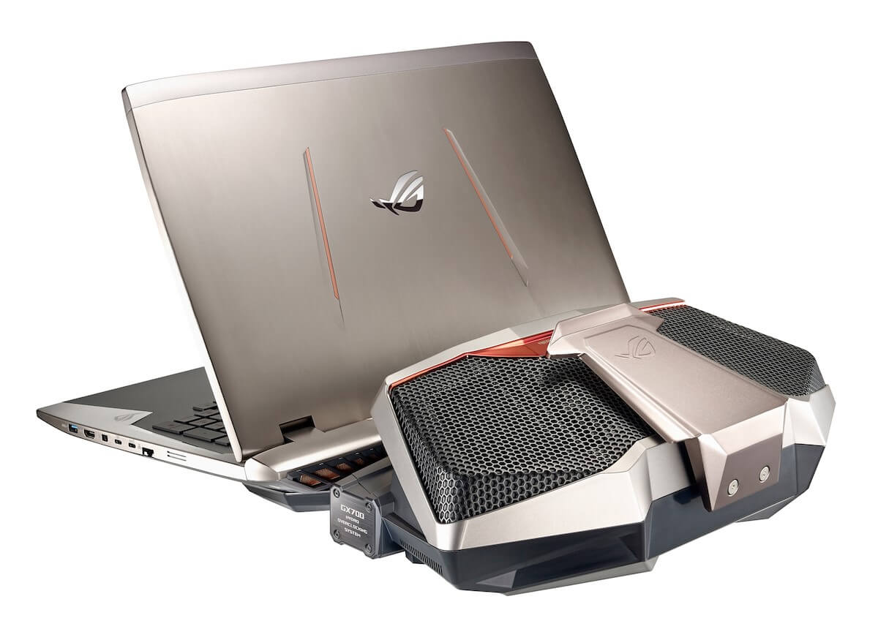](http://www.pcmarket.com.au/shop/asus/notebooks/asus-rog-gx700vo-gc009t-intel-core-i7-6820hk-173-fhd-gaming-notebook-windows-10)

ROG GX700VO: <http://www.pcmarket.com.au/sites/default/files/notebooks/7157/gx7001.jpg>

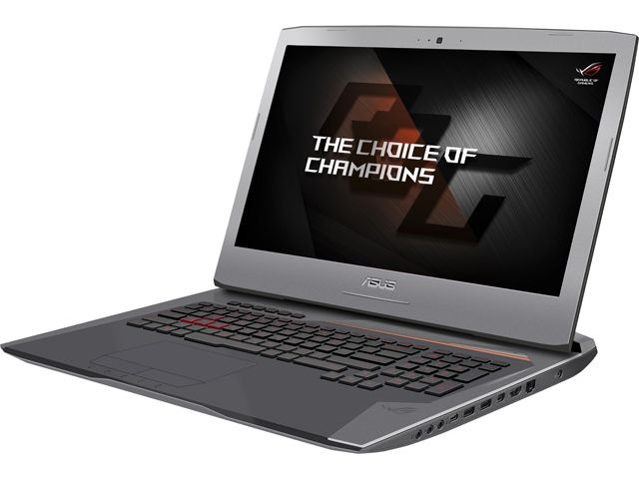ROG G752VT:

<http://images10.newegg.com/ProductImage/34-232-766-23.jpg>;

**MSI Pictures:**

[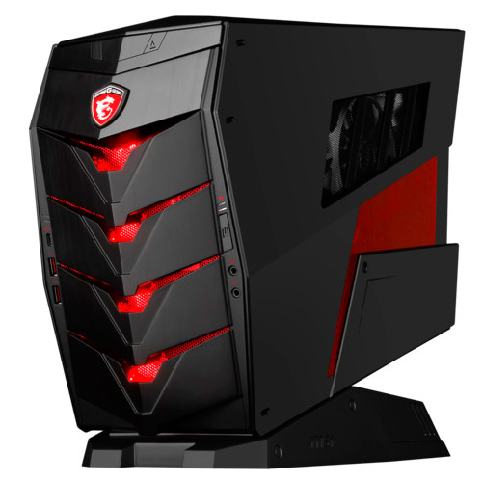](http://techreport.com/news/30024/msi-aegis-barebones-shields-gamers-from-low-frame-rates)

Aegis:

<http://techreport.com/r.x/2016_4_22_MSI_launches_Aegis_tiny_gaming_barebones/10519-msi-aegis-1.jpg>

**Razer Blade Pictures:**

[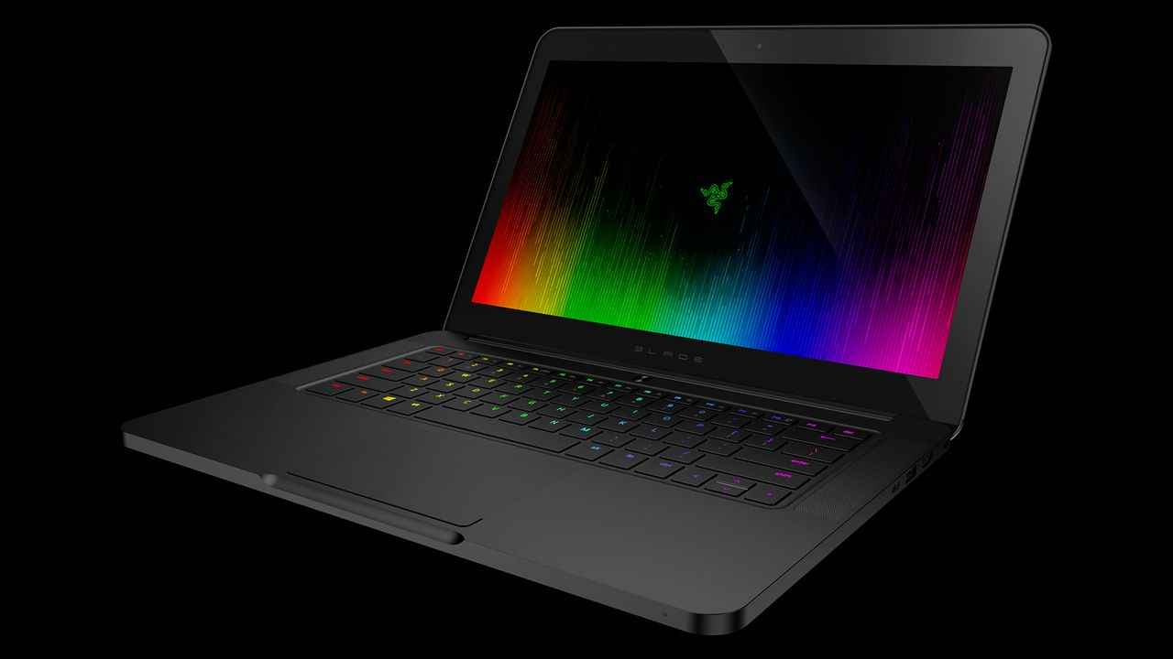](https://www.google.com/url?sa=i&rct=j&q=&esrc=s&source=images&cd=&ved=0ahUKEwicgKabo9LNAhUH44MKHUyFBl4QjRwIBw&url=http://www.polygon.com/2016/3/15/11217376/razer-blade-laptop-new&psig=AFQjCNFH1arC9EpGdAj9YFtQZBFIx6r_4A&ust=1467462834801859)

The new Razer Blade:

<https://cdn0.vox-cdn.com/thumbor/lgs9GTFGj0UWRVfFXn0YKs5lIxc=/0x0:1920x1080/1280x720/cdn0.vox-cdn.com/uploads/chorus_image/image/49075319/razer-blade-2016-model_1920.0.0.jpg>

**Alienware Pictures:**

[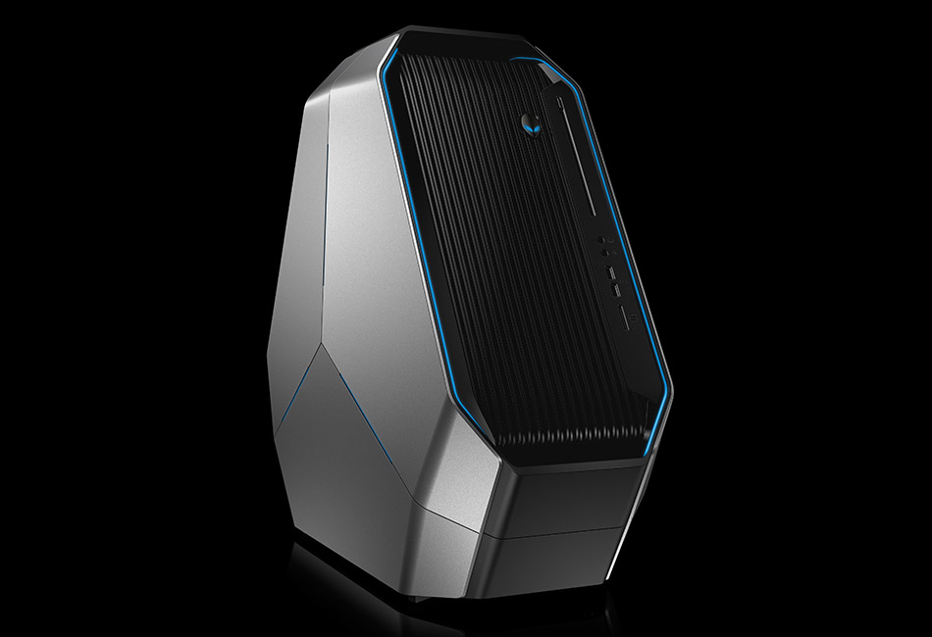](https://www.google.com/url?sa=i&rct=j&q=&esrc=s&source=images&cd=&ved=0ahUKEwjduKHWpNLNAhUE8IMKHV5ZAMEQjRwIBw&url=http://www.alienware.co.uk/landings/desktops.aspx&bvm=bv.125801520,d.amc&psig=AFQjCNF1PPUSRSoJ7OXfJVFJQSpBmih2pQ&ust=1467463224288199)

Area 51:

<http://image.alienware.com/images/galleries/Area-51/gallery-shot_desktops_area51_02.jpg>

**Origin PC Pictures:**

[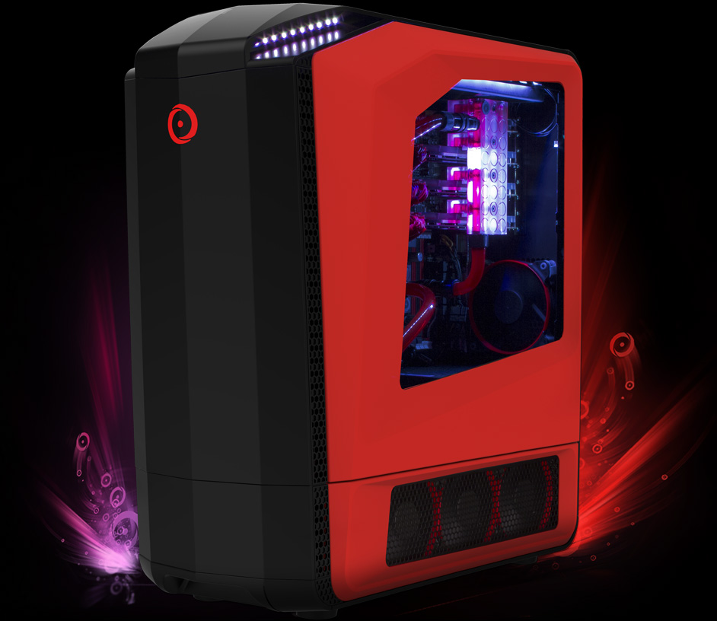](https://www.originpc.com/gaming/desktops/genesis/)

Genesis:

<https://origincdn.azureedge.net/cdn/gaming/desktops/Genesis/img/genesis-main-red-mid-left2.jpg>